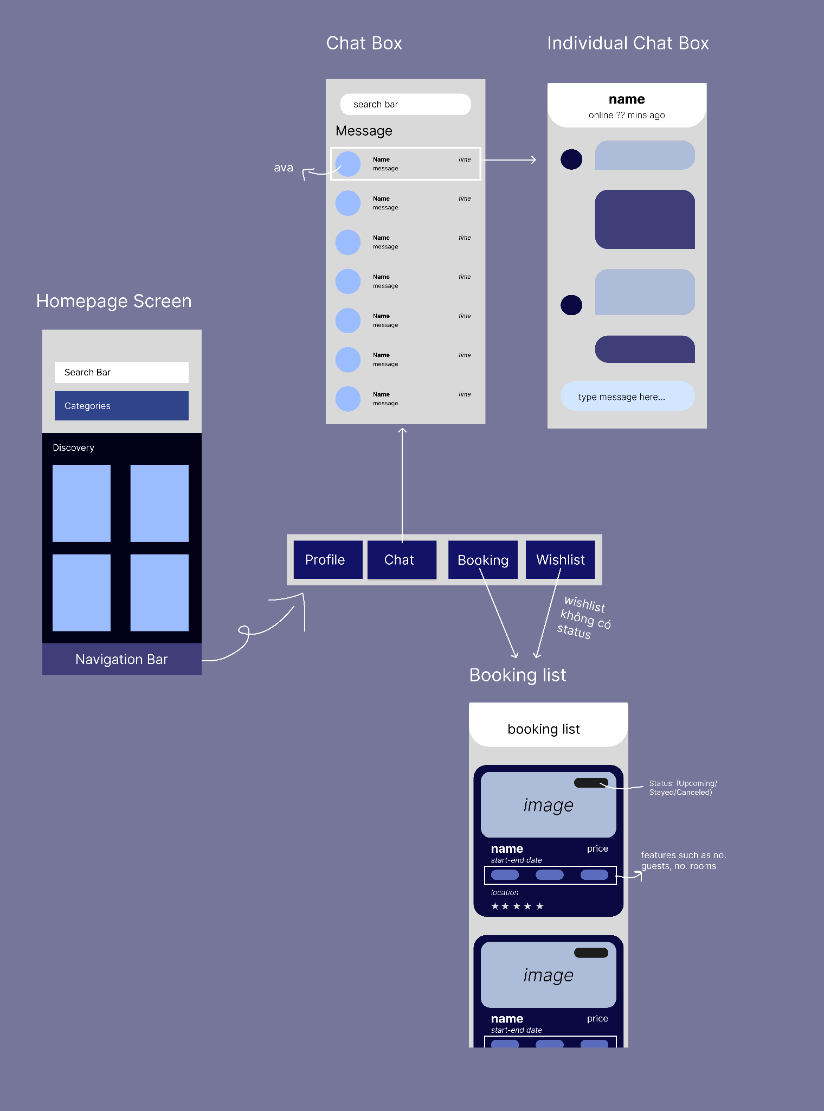

# Explore (Homepage) Page

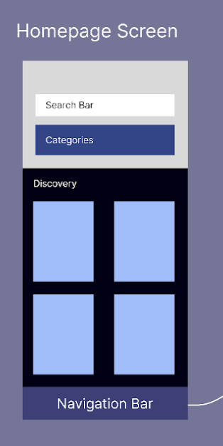

This screen consists of:

1. Bottom Navigation Bar: Will leads renters to his/her profile/setting page, their chatbox, their booking list and wish list screen respectively.
2. Search Bar: Placed at the top of the screen, when users tap in this search bar, they will be navigated to a search screen which allows users to search particular accommodation by name and filter or sort the results as they like.
3. List of accommodation’s categories: Users can view accommodations of certain category by tapping the corresponding category
4. The previews of accommodations: Is a scroll view that displays images and some basic information such as names, addresses and prices of particular accommodations. If a user is interested in any accommodation, they can view the detailed information by clicking the corresponding images.

# Chat Page

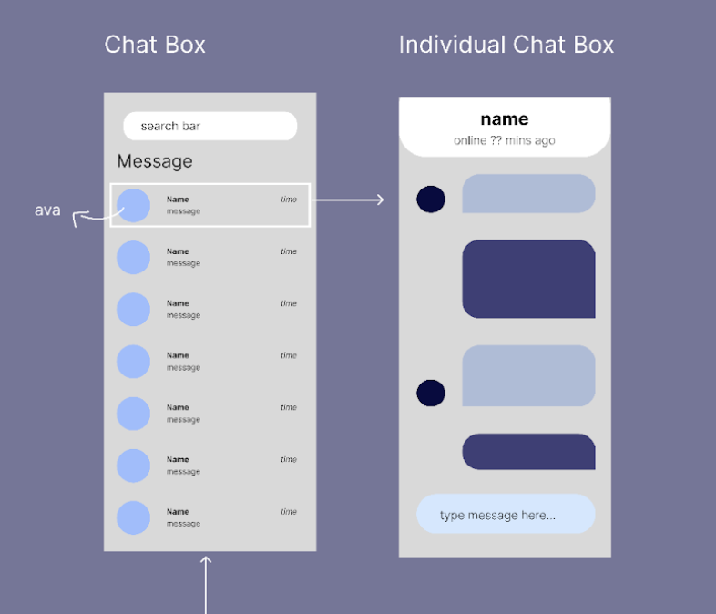

## Chatbox

This screen consists of:

* Search bar: Placed at the top of the screen, this field receives input as a username to sort out possible chatboxes between this user and users that have the best fit name.
* List of Individual Chatbox: this field displays a list of chatboxes (rectangular frame with represented profile image, username and latest activity) of this user which is sorted by newest message. User can view the detail of the conversation by click the compatible chatbox and will be forwarded to individual chatbox.

## Individual Chatbox Page

This screen consists of:

* Profile image: on the left border of the screen. This image represents the user in the conversation with this user and lies in the same row with the compatible chat text
* Chat text: in the center of the screen, the text is displayed by time order and appears compatible with the user.
* Message Input: on the bottom of the screen, a keyboard will pop up when the user touches this field and it tells the user to input a message and press enter to send into the conversation.
* Status bar: On the top of the screen, this displays the other user name and their status.

# Reservation Page

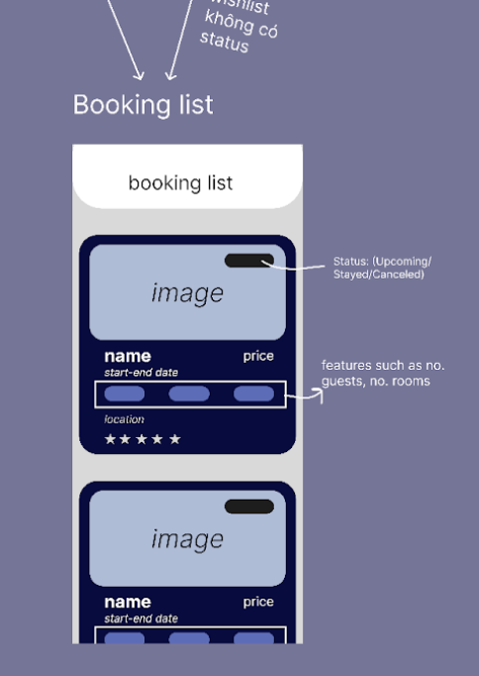

This screen consists of:

* List of Accommodation view: this contains accommodation boxes this user did book with detailed entities.
* Image: the thumbnail image of the accommodation
* Status:Upcoming/Stayed/Canceled
* Name: Name of a place
* Price: Price of the accommodation per night
* Feature: display feature of the accommodation as Air conditioning,etc
* Location: the location of the place
* Rating: 5 colored stars